# **Review Log**

Overview:

The NAHLN Messenger allows for institutions to monitor the successes and failures of their NAHLN messages on an easy to use frontend dashboard.

The Review Log allows users to review various data points for the messages being sent.

Processes

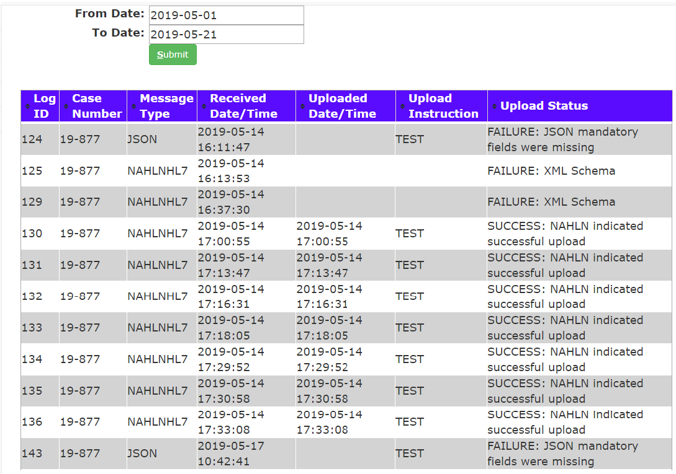

The datapoints captured on the Review Log screen are as follows:

1. Log ID:
2. **Case Number:** The VADDS case number from which the message was sent
3. **Message Type:** Defines weather the message is written in JSON or HL7 (called NAHLNHL7 here)
4. **Received Date/Time:** The date and time the message was sent
5. **Uploaded Date/Time:** The date and time the message was uploaded to NAHLN
6. **Upload Instruction:** For all messages that are not active, TEST will be sent. For all active, LIVE will be sent. This can be presently turned on or off in the CCR ‘nahlntst’ script line 2.
7. **Upload Status:** The upload status indicates weather or not the messages were successfully sent, or if it failed. If a failure occurs, a reason is provided. Example statuses in attached image.