# **Update Profile**

Overview:

The NAHLN Messenger allows for institutions to monitor the successes and failures of their NAHLN messages on an easy to use frontend dashboard.

The Update Profile tab allows authorized users to update various datapoints for their institutions VADDS Messenger Portal. Datapoints explained in detail below.

Processes  
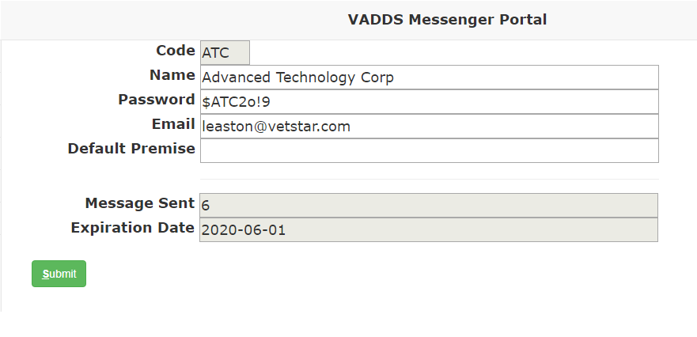

The datapoints captured on the Update Profile tab include:

1. **Code:** This field can only be modified\adjusted by ATC staff. This is the code you use to login to the NAHLN Dashboard. If you would like this cod changed, please reach out to your VADDS contact.
2. **Name:** The name of your institution.
3. **Password:** Secure password to access the NAHLN dashboard. This is your password to login to the dashboard.
4. **Email:** This is the email address that will be alerted when failures arise.
5. Default Premise:
6. **Message Sent:** This is the total number of messages sent.
7. **Expiration:** The expiration date is the date in which the annual maintenance for the NAHLN Dashboard is valid through. To extend the maintenance for this feature, payment is required.